**Project 2 – US mortality rate**

**Chosen Topic:**

Mortality rate in the US and its classifications.

The group chose to evaluate information on death by State and/or county in the United States. The data is also separated by cause of death. The scope of the project will be to provide a dashboard of the selected dataset, that will help people visualize the death rates and its causes as it spreads through the US since 1980 up until 2014. There will be some forms of interaction added, so that the user will be able to customize his/her visualization. If the timeframe allows, the group intend to bring a second dataset that might help explain a specific cluster identified.

**Dataset:** ( <https://www.kaggle.com/IHME/us-countylevel-mortality> )

The dataset named “US county-level mortality” was found in Kaggle. The dataset is in CSV format and will be loaded into SQL server.

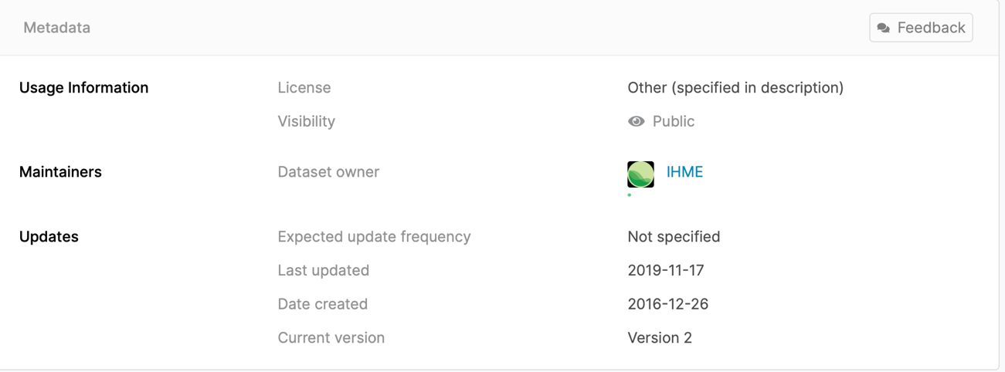

**Visualization Ideas:**

1. 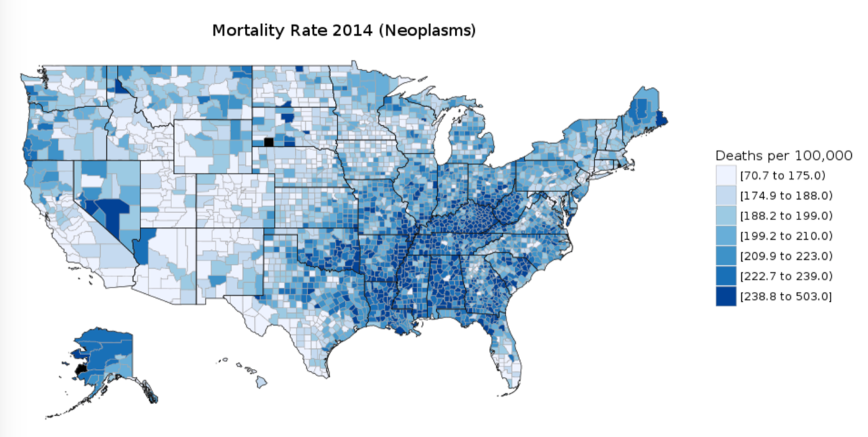Overall map of the US. Interactive by year.
2. Death rate by cause of death(https://plot.ly/python/wind-rose-charts/)

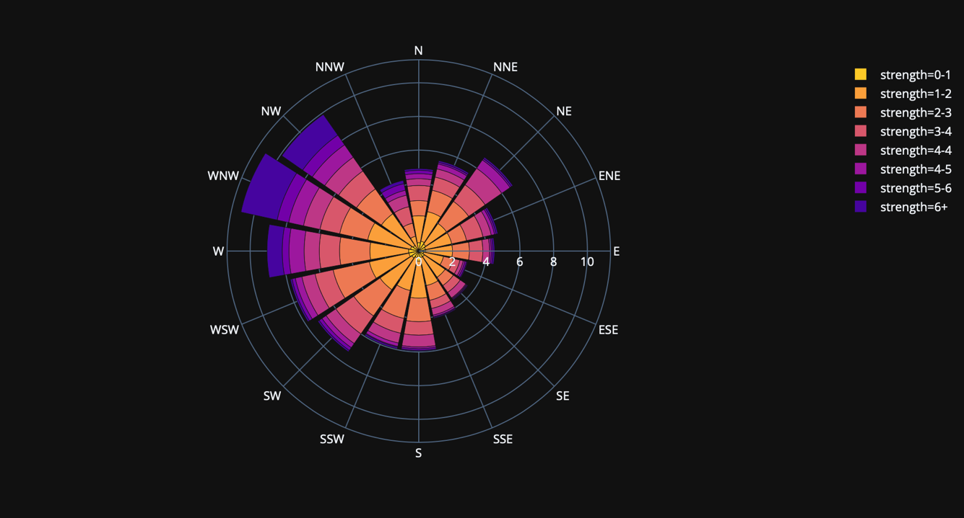

1. Pick a cause of death and watch the evolution over the years

